**ME 111**

**Projection of Solids**

|  |  |  |
| --- | --- | --- |
| 1 | A cylinder 40 mm diameter and 50 mm axis is resting on one point of a base circle on VP while it’s axis makes 450 with VP and FV of the axis 350 with HP. Draw projections. | 30 |
| 2 | A cone of diameter of base 60 mm and axis length equal to 100 mm rests on a point of its periphery of the base on H.P. such that its axis is inclined at an angle of 35° with the H.P. and 60° with the V.P. and the apex is near to the observer. Draw its projection. | 35 |
| 3 | A hexagonal prism of 30 mm side of base and 70 mm height, resting on the H.P. such that the axis is inclined at 300 to the H.P. and 600 to the V.P. Draw its projections. Keep the top end of the prism near to the V.P.  . | 35 |

**Solution**

**1**

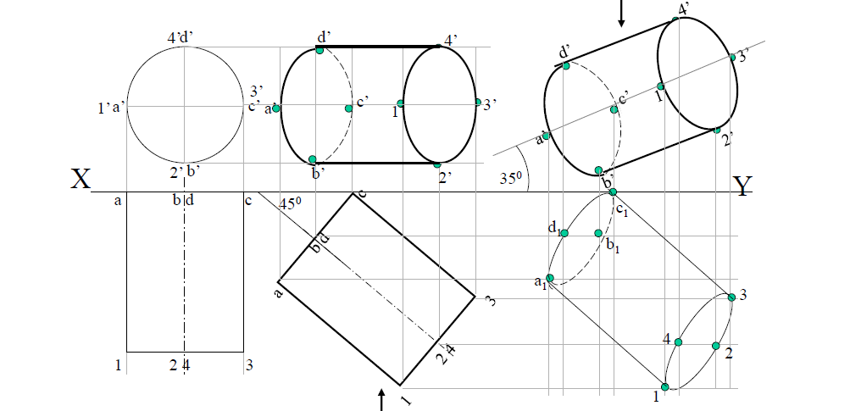

**2**

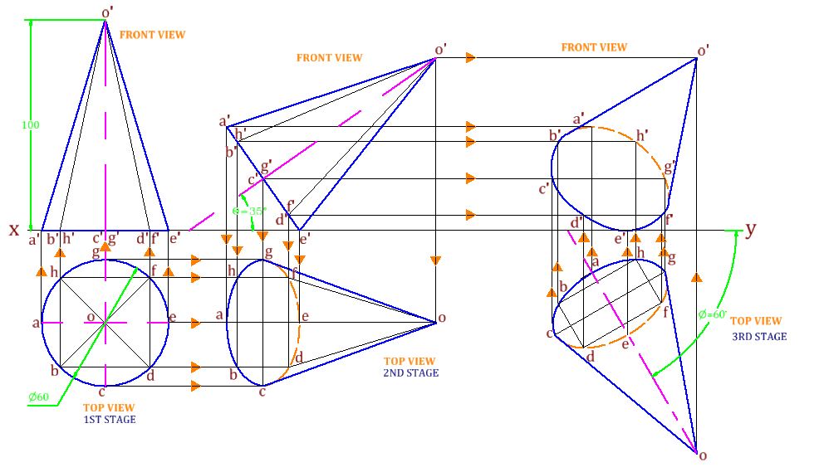

**3**

